- Open the playground: https://killercoda.com/playgrounds/scenario/ubuntu
- Run the Airflow container:
docker run -d -p 8080:8080 --name airflow apache/airflow standalone
- Check whether the container is running:
docker ps
- View the logs to get the Airflow username and password:
docker logs airflow
- In the logs, search for lines similar to:
Standalone mode
Login with username: admin
Password: xxxxx
- On the right side of Killercoda, click the hamburger menu (☰).
- Click Traffic / Ports.
- Open port 8080.
- Airflow UI will open in the browser.
- Login using:
- Username: admin
- Password: the password shown in docker logs airflow output.

Run this command to enter the Airflow container terminal:

docker exec -it airflow bash

After entering, your prompt will change similar to:

airflow@container-id:/opt/airflow$
go inside dag folder: cd /opt/airflow/dags
cat > first_dag.py
Use this command inside the Airflow container to create the DAG file
Then paste the DAG code.
After pasting, press:CTRL + D to save file
Cmd ls to see if file exist
If file exist then exit cmd
Then cmd:
docker restart airflow
>>go to airflow
after 2mins refresh
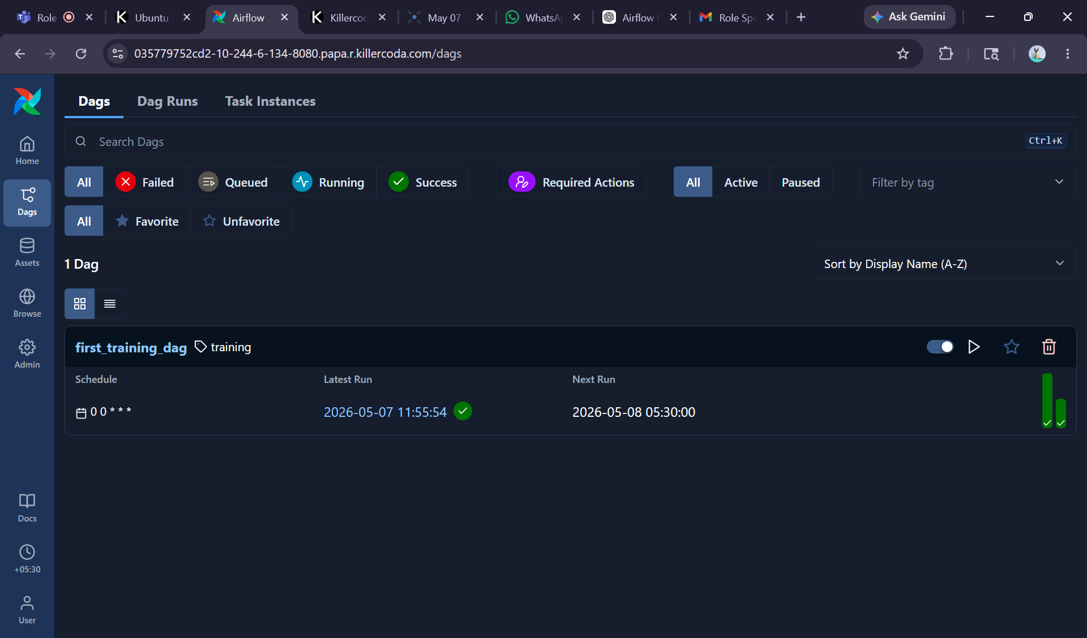
Enable toggle and click the run button.
Click on first _training_dag
U can see
